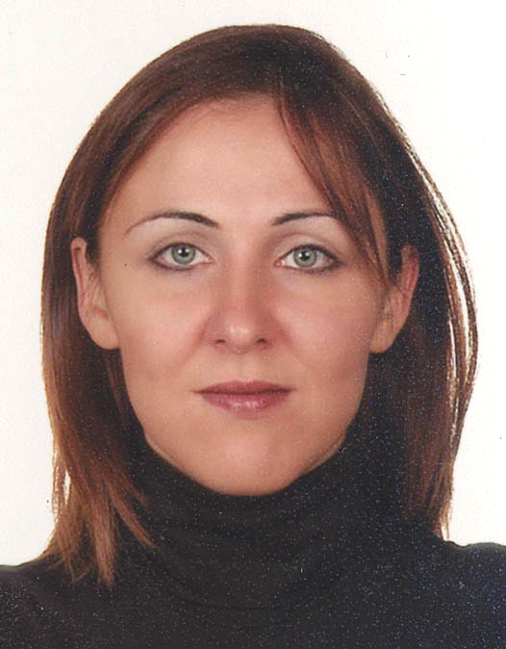
CURRICULUM VITAE

CINAR, BASAK AYSE

Born
22 June 1973

Gender
Female

Nationality

Turkish

Office Address
Institute of Dentistry, P.O.Box 41, University of Helsinki, Finland
Tel +358 191 27203 e-mail: basak.cinar@helsinki.fi

Education and training
PhD, Institute of Dentistry, Oral Public Health Care Department, University of Helsinki, Finland | 2001-2008
Master of Behavioral Sciences, Business Administration Faculty, Istanbul University, Turkey | 2001
Hospital Management Certificate Program, Business Administration Faculty, Istanbul University, Turkey | 1998
Licentiate of Odontology, University of Marmara, Turkey | 1996

Professional appointments
Visiting international researcher and pediatric dentist, Paediatric Dentistry Department,  Faculty of Dentistry, Yeditepe University | 2004-2005
Instructor of Organizational Behaviour Sciences, Business Administration Faculty,  Yeditepe University | May-September 1999
Volunteer Medical Assistant, Marmara Hospital & Yalova Earthquake Tents, 1999, Yalova Earthquake, Turkey | August-September 1999
Hospital Management Trainee, Şifa Hospital, Istanbul, Turkey | November –December 1998
Hospital Management Trainee, American Bristol Hospital, Istanbul, Turkey | August- October 1998
Hospital Management Trainee, Memorial Hospital, Istanbul, Turkey | May- July 1998
Scientific Experimental Studies Assistant, Haydarpasa Numune Hospital, Istanbul, Turkey | 1996–1999
Mete Fanuscu & Teoman Fanuscu Dental Clinic, Private Dentist, Istanbul, Turkey | 1995–1998

Academic awards and grants
International Student Grant for outstanding postgraduate students  L’OREAL- UNESCO Women in Science Awards 2004 | November 2008  December 2003
Turkish Ministry of National Education Bilateral Scholarship  (Short-term research on dental anxiety in University of Helsinki) | Spring 2001
Honorary Degree, Hospital Management Certificate Program, Istanbul University, Turkey | 1998

Memberships
IADR | 2002-
International Society of Behavioural Medicine, Education and Training Special Interest Group | 2002-

Publications
Preadolescents and Their Mothers as Oral Health-Promoting Actors: Non-biologic Determinants of Oral Health among Turkish and Finnish Preadolescents. Thesis for Doctorate in Dentistry. University of Helsinki, Institute of Dentistry, Oral Public Health Department, November 2008.

A holistic food labelling strategy for preventing obesity and dental caries. Cinar AB, Murtomaa H. Obesity Reviews 2008 (ahead of print)

Clustering of Obesity and Dental Health with Life-Style Factors among Turkish and Finnish Pre-adolescents.
Cinar AB, Murtomaa H. Obesity Facts 2008; 1:196-202.
The Life-course Approach in Assessment of Dental Health among Finnish and Turkish Pre-adolescents.
Cinar AB, Tseveenjav B, Murtomaa H. European Journal of Dentistry 2008 (ahead of print).
Comparison of Psychosocial Factors Related to Dental Anxiety among Turkish and Finnish Pre-Adolescents.
Cinar AB, Murtomaa H. Oral Health & Preventive Dentistry 2007; 5:173-179.

Individual and maternal determinants of self–reported dental health among Turkish school children aged 10-12 years.
Cinar AB, Kosku N, Sandalli N, Murtomaa H. Community Dental Health 2008; 25:84-88.
Health-related Self-efficacy Beliefs and Tooth-brushing: Social Cognitive Theory Based Comparison of Finnish and Turkish Pre-adolescents’ and Mothers’ Responses.
Cinar AB, Tseveenjav B, Murtomaa H. Oral Health & Preventive Dentistry (Accepted for publication, March 2008).
Self-Efficacy Perspective on Oral Health among Turkish Preadolescents.
Cinar AB, Kosku N, Sandalli N, Murtomaa H. Oral Health & Preventive Dentistry 2005; 4: 209-215.
Behaviour Concept at Medical Sciences.
Cinar AB. Online Lecture. http://www.pitt.edu/~super1/lecture/lec9201/index.htm (21 January 2003)
Communication; its vitality and essence: Patient-Doctor Relations and a New Health Behaviour Model.
Cinar AB. Thesis for Master of Behavioral Sciences. University of Istanbul, Business Administration Faculty, Behavioural Sciences Department, May 2001.
Effect of hematocrit on blood pressure via hyperviscosity. Cinar Y, Demir G, Pac M, Cinar AB.American Journal of Hypertension 1999;12:739-743.

Posters presented
Self-efficacy, School Performance and Oral Health-Related Lifestyle among Turkish and Finnish Pre-adolescents  Cinar AB, Sandalli N, Murtomaa H. 2008 FDI Annual World Dental Congress, Stockholm, SWEDEN | 24-27 September 2008
Individual and Maternal Determinants of Pre-adolescents’ Self-Reported Dental Health  Cinar AB, Sandalli N, Murtomaa H. The IADR 86th General Session & Exhibition, Toronto, CANADA | 2-5 July 2008
Dental Health and Obesity among Turkish and Finnish Pre-adolescents  Cinar AB, Cinar Y, Murtomaa H. 5th Metabolic Syndrome Symposium, Antalya, TURKEY | 9-13 April 2008
Accuracy of Blood Glucose Estimation Among Diabetes Mellutus Patients  Cinar Y, Cinar BA, Rezan GKY. 5th Metabolic Syndrome Symposium, Antalya, TURKEY | 9-13 April 2008
Relations of Testosterone, Metabolic Syndrome, Diabetes and Coronary Heart Disease  Cinar Y, Cinar BA , Kacmaz Y. 5th Metabolic Syndrome Symposium, Antalya, TURKEY | 9-13 April 2008
Life-course approach in assessment of dental health and biological development of pre-adolescents  Cinar AB, Murtomaa H. The EUPHA Helsinki Pre-Conference, the 18th Nordic Conference, Social Medicine and Public Health, Helsinki, FINLAND | 10-11 October 2007
Differences in Oral Health and its Determinants among Finnish and Turkish Preadolescents  Tseveenjav B, Cinar AB, Murtomaa H. Finnish Dentists’ Annual Meeting, Helsinki, FINLAND | 16-18 November 2006
Clinically- and Self- Assessed Oral Health of Turkish Children  Cinar AB, Kosku N, Sandalli N, Murtomaa H. First African and Middle-East IADR Federation Conference, KUWAIT | 27-29 September 2005
Toothbrushing Self-Efficacy Scales for Preadolescents: Pilot Study  Cinar AB, Kosku N, Sandalli N, Murtomaa H. IADR/CED/NOF Divisional Meeting, Istanbul, TURKEY | August 2004
Role of maternal modeling on oral health behavior of children: Pilot Study  Cinar AB, Murtomaa H. 8th Annual Conference of the European Association of Dental Public Health, Jyväskylä, FINLAND | 21-23 August 2003
A New Paradigm on Evaluation of Health Promotion: A New Oral Health Behaviour Model for Late Childhood  Cinar AB, Murtomaa H. 4th Nordic Health Promotion Research Conference, Västerås, SWEDEN | 11-13 June 2003

Other congresses, seminars and academic activities
STATA9: Efficient and easy software for medical statistics, Finnish Cancer Registry,  Helsinki, FINLAND  Seminar on Scientific Writing & Global Determinants of Health, Lämmi, FINLAND | 10-13.October.2008  12-13 September 2008
North Karelia Project: International Visitors’ Programme, National Public Health Institute, Helsinki, FINLAND | 4-6 September 2006
Postgraduate Courses, Helsinki University and Tampere University, FINLAND | 2001 - 2005
Oral Public Health Trainer Certificate, Istanbul Dental Association, Istanbul, TURKEY | December 2004
7th International Congress of Behavioural Medicine, Helsinki, FINLAND | 28-31 August 2002
Computer Games and Digital Culture Conference, Tampere, FINLAND | 6–8 June 2002
5th Congress of European Academy Paediatric Dentistry, NORWAY | June 2000
International Congress of Endodontics, Istanbul, TURKEY | May 2000
Meetings of Health Care Quality Association, Istanbul, TURKEY | 1999-2000
From Industry to Health Business Excellence Model Symposium, BILMEDYA GROUP, Istanbul, TURKEY | 1999
Techniques of Training, YUMLU Education Foundation, Istanbul, TURKEY | 1999
Mediterranean Congress of Oral and Maxillofacial Surgery, Antalya, TURKEY | May 1997
The Seminars, Congresses and Panels, Istanbul Dental Association and EDAD,  Istanbul, TURKEY | 1996–1999

Languages
Turkish – fluent
English – fluent
Finnish - little

Software literacy
WINDOWS Operating Systems
MS Office (Outlook, Word, Excel, PowerPoint, HTML)
Statistics (SPSS)

Other interests
Drawing, poetry, writing, philosophy, psychology, behavioral Sciences, health nutrition
sports activities and Pilates

